Parse HAR JSON for each webpage and extract relevant information

Madhur Singhal - 2015CS10235, Anant Chhajwani - 2015CS50281

1. Total number of objects downloaded by different web pages

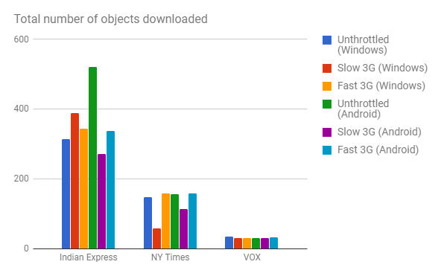

Number of objects downloaded by Indian Express webpage > Number of objects downloaded by NY Times webpage > Number of objects downloaded by VOX webpage

2. Total size of content downloaded by different web pages

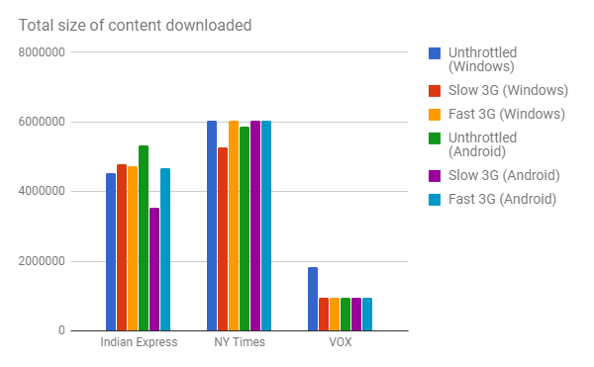

Size of content downloaded by NY Times > Size of content downloaded by Indian Express > Size of content downloaded by VOX.

Although the number of objects downloaded by NY Times were less than those by Indian Express, the total content size downloaded is found to be opposite.

It is observed that Slow 3G profile shows less size of content downloaded.

3. Total number of TCP connections opened to download different web pages

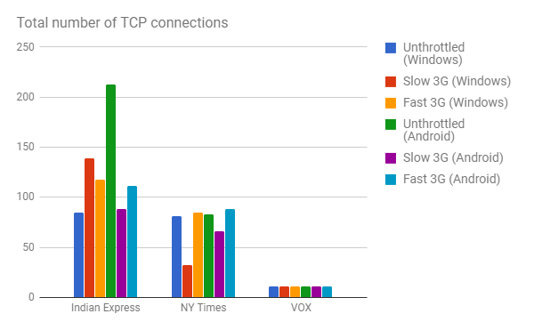

Number of TCP connections opened by desktop browser is more or less equal to that by mobile browser except for unthrottled profile of Indian Express which opened more connections in mobile than desktop.

Also, number of TCP connections opened in Slow 3G are less than number of TCP connections opened in Fast 3G.

A cap is imposed by browser on number of objects downloaded per TCP connection to at most 20.

4. Average achieved goodput of network

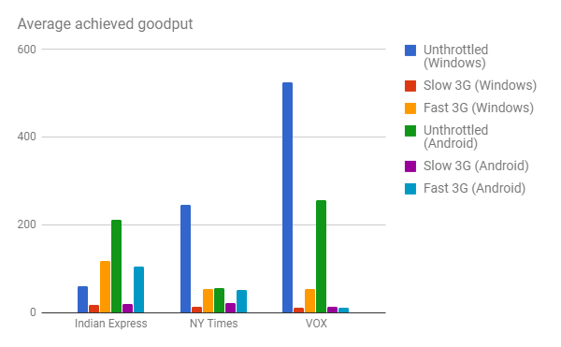

Average achieved goodput is measured as total size of content downloaded over all TCP connections divided by total time spent in receiving data.

It is observed that average achieved goodput is high in unthrottled and fast 3G profiles, while it is low for slow 3G profile.

5. Maximum achieved goodput across all connections

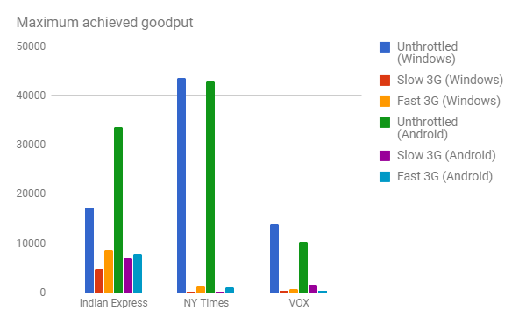

The maximum achieved goodput of a TCP connection is calculated using the size of largest object downloaded on that TCP connection divided by time to receive the largest object.

The download capacity was not utilized well to access the web pages since the average goodput of network is significantly less than maximum of the maximum achieved goodput across all connections.

6. Page load time from onLoad entry

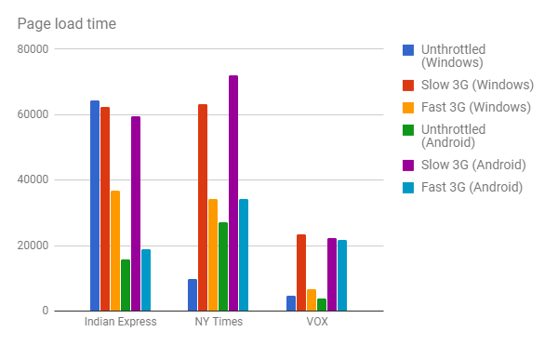

The page load time is an accumulation of all of the following : connection establishment time, DNS query resolving time, request, receive and wait times.

It is observed that page load time is highest in slow 3G profile for all web pages and for both desktop and mobile browsers.

7. Best page load time obtained by collapsing all GET request on a TCP connection

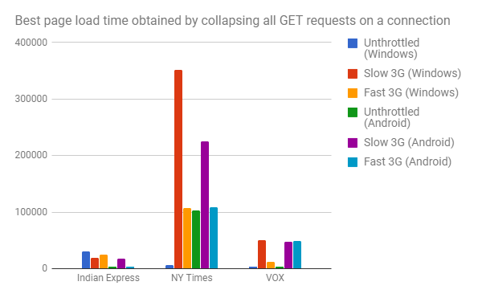

Best page time is obtained by collapsing on each TCP connection all the GET requests, so that the objects are received back to back and there are no idle times.

Therefore, the total time consumed on the TCP connection as the sum of the connect time for the TCP connection, the maximum of the waiting times for objects downloaded on that connection, the sum of the send times, and the sum of the receive times.

Also assume that all the connections could have been opened simultaneously and calculate the maximum of the times for each connection and add to this the maximum of the DNS time.

Best page load time is significantly less than actual page load time. This takes less time because we consider maximum over all waiting times for objects downloaded on each connection rather than adding them up.

We also ran another calculation assuming that all content from a domain can be downloaded on a single TCP connection at the maximum achieved goodput seen for that domain. This page load time calculation was also less than actual value as observed from onLoad entry of HAR file.